Assignment #12 Text Mining SAS by Joshua Troup

1. Show your completed process flow diagram (screenshot) covering the above steps. Documenting the above steps will be highly recommended and will also serve you as a ready reference for future use.

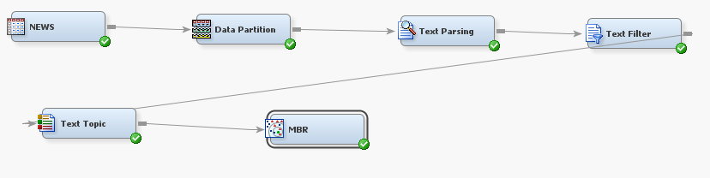

1. From the MBR Results, present your Classification Matrix both in graphical form and as a Matrix table (showing training and validation datasets)

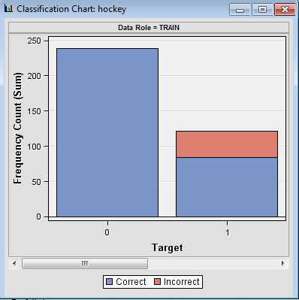

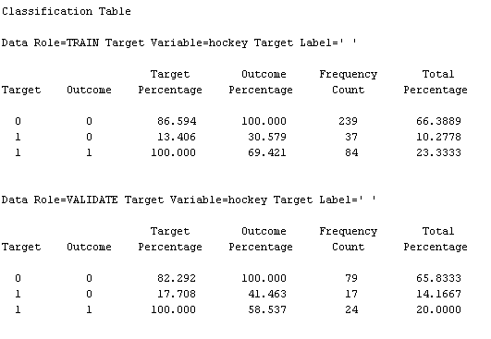

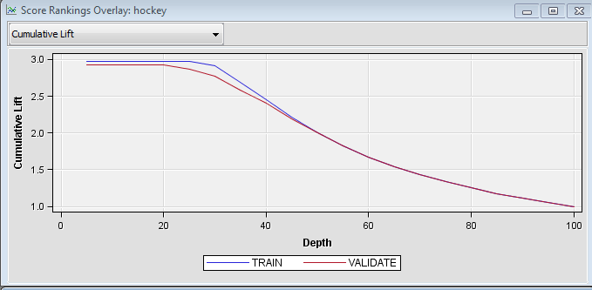

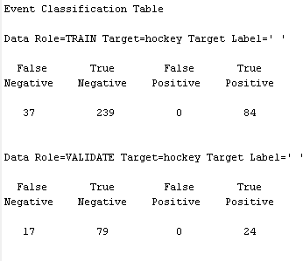

3. Interpret the classification (confusion) matrix and submit the following: (success as 1)

• Number of articles correctly classified into the hockey category as 1 (TP) **24**

• Number of articles that belong in the hockey category are misclassified (TN) **79**

• Number of articles correctly predicted as 0 (FP) **0**

• Number of articles that do not belong in the hockey category are misclassified (FN) **17**

• The overall correct classification rate **86% (66+20)**

• Precision and recall (use the formulas learnt in data mining course)**Precision = 1**

**Recall = .5853**

1. Submit the new process flow diagram used to score a new document sample dataset b) Submit your results as a bar chart showing the categories (0,1) output for training, validation, test and scoring.

